### Problem Statement

Toronto is a large city and it is not easy for an Indian migrating to Toronto to determine the neighbourhood he should choose to settle down as it has a lot of diversity in demographics and various other factors. Let us take the number of Indian restaurants in the neighbourhood to choose which neighbourhood would be best for him to settle down.

We will visualise all neighbourhoods of Toronto using Folium and also compare the number of Indian restaurants as a parameter to choose the best place to settle down.

### Data

#### For this project we need the following data:

Data source: <http://cocl.us/Geospatial_data>

Description: We will use this data for Toronto City if required, which contains a list of Neighbourhoods along with their latitude and longitude.

Data source: Foursquare API

Description: Using Foursquare API, we will get all the venues in each neighbourhood and then we will filter these venues for only Indian restaurants.

### Solution methodology

From the above 2 data sources, I conducted neighbourhood analysis leveraging primarily Foursquare APIs and Folium Map to deliver recommendations options to the target user community primarily comprising of the Indian community.

I did this in below steps –

1. Used Four square to get the data of the Indian Restaurants along with their Latitude and Longitude.
2. This was kept within the radius of 10 Km.
3. Formatted the data and loaded into a Python Dataset.
4. Cleansed the data for any anomalies like
   1. To remove any row having no address
   2. To remove any row having no State
   3. To remove any row having no Postcode
5. Plotted the Indian Restaurants on top of the Toronto Map.
6. Sliced the dataset to have only Postal code, Latitude and Longitude.
7. Grouped the data on the first three letter of Post codes to get the Boroughs.

### Map of Toronto with Indian Restaurants

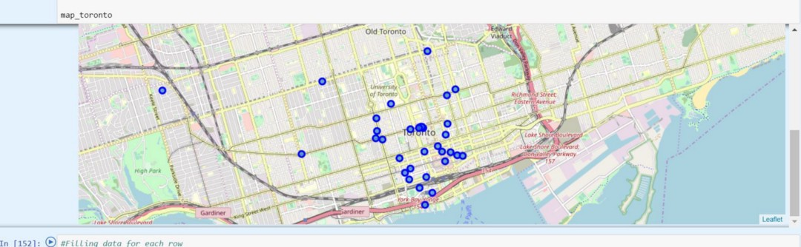

Map of Indian Restaurants in Toronto

### Results

The highest count of Indian Restaurants are in

M5G- count of the Indian restaurant is 6

M5T- count of the Indian restaurant is 5

M5V- count of the Indian restaurant is 5

We can see that postal code starting with M5G is the best place. Second best place for an Indian would be M5T and M5V. Quick search in Wikipedia “[https://en.wikipedia.org/wiki/List_of_postal_codes_of_Canada:_M"](https://en.wikipedia.org/wiki/List_of_postal_codes_of_Canada:_M%22)indicates that

for M5G Borough is “DownTown Toronto” for M5T Borough is “DownTown Toronto” for M5V Borough is “DownTown Toronto”

### Recommendations

With this, we conclude that for any new Indian, it would be best to settle down near “DownTown Toronto” on the basis of the number of Indian Resturants.

-Bhanu